C:\>md demo

C:\>cd demo

C:\demo>echo "Hello World!" > Hello.txt

C:\demo>exit

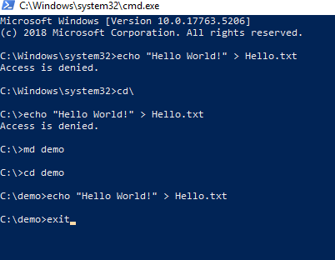

nerdctl ps -a



sudo snap install dotnet-sdk --classic --channel=6.0

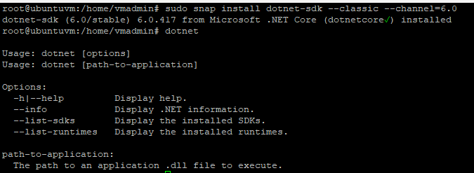

dotnet new webapp -n AspNetCoreDemo -o firstwebapp

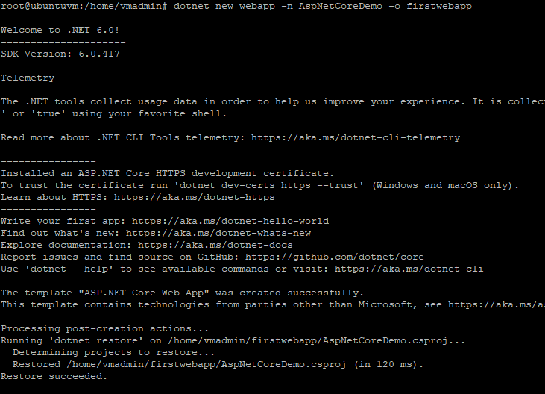

You have created your first application. The next task will be to run it. Change the directory to the project folder, and run dotnet run.

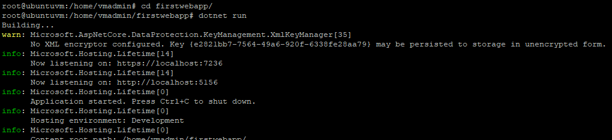

# Add Docker's official GPG key:

sudo apt-get update

sudo apt-get install ca-certificates curl gnupg

sudo install -m 0755 -d /etc/apt/keyrings

curl -fsSL https://download.docker.com/linux/ubuntu/gpg | sudo gpg --dearmor -o /etc/apt/keyrings/docker.gpg

sudo chmod a+r /etc/apt/keyrings/docker.gpg

# Add the repository to Apt sources:

echo \

"deb [arch=$(dpkg --print-architecture) signed-by=/etc/apt/keyrings/docker.gpg] https://download.docker.com/linux/ubuntu \

$(. /etc/os-release && echo "$VERSION_CODENAME") stable" | \

sudo tee /etc/apt/sources.list.d/docker.list > /dev/null

sudo apt-get update

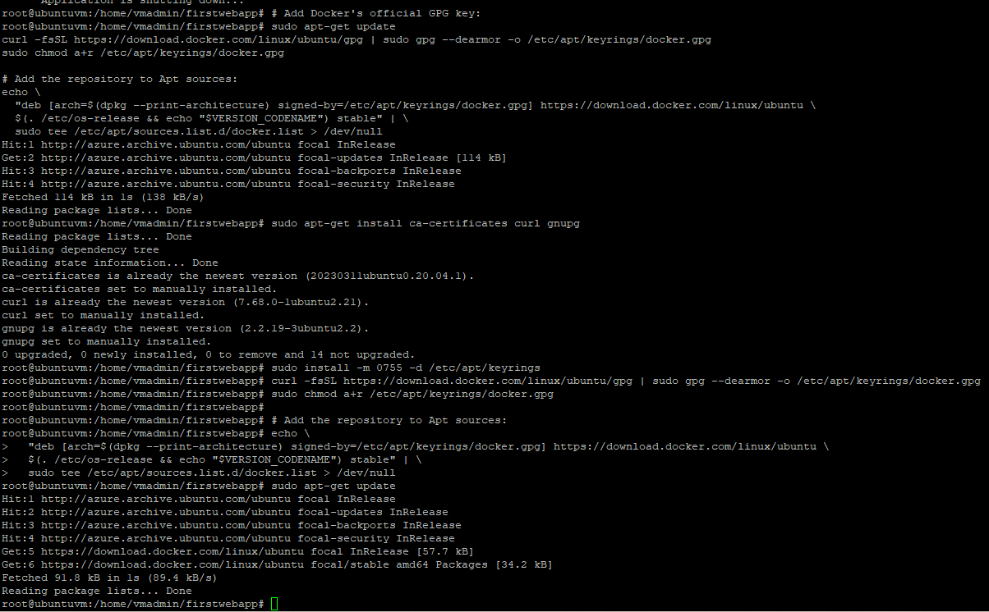

sudo apt-get install docker-ce docker-ce-cli containerd.io docker-buildx-plugin docker-compose-plugin

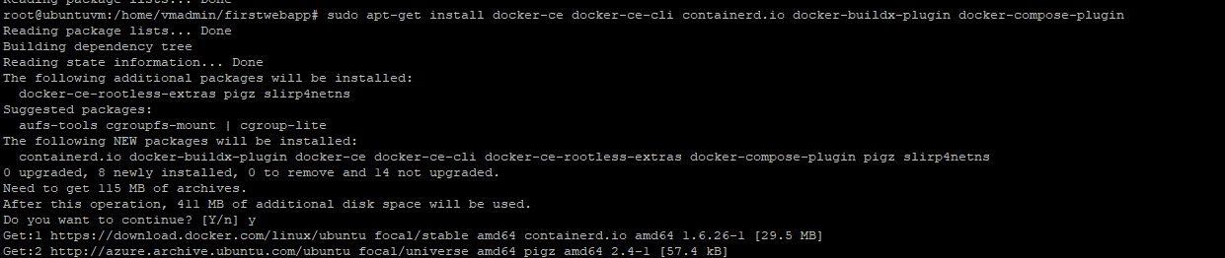

sudo docker run hello-world

